- Download a sample credit card fraud dataset (with imbalanced classes) from Kaggle or UCI, split it into train and test sets, and train a logistic regression classifier using scikit-learn.
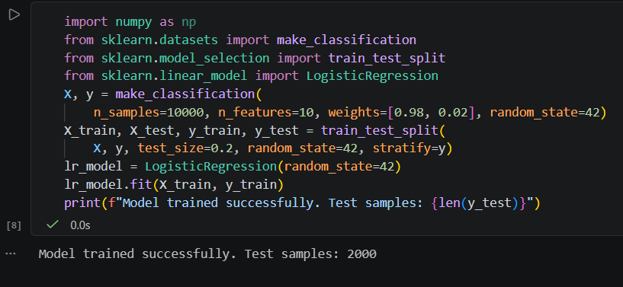

- Plot the ROC curve for your classifier using sklearn.metrics.roc_curve and matplotlib, and display the AUC score on the plot.
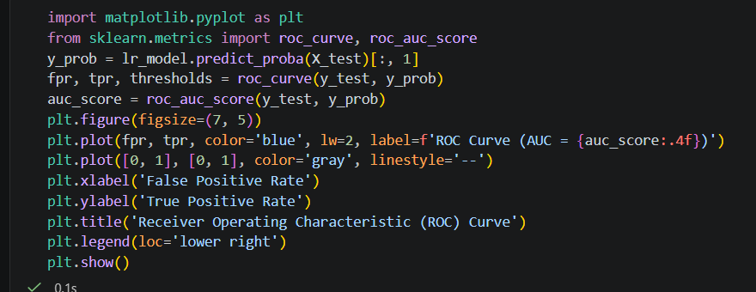

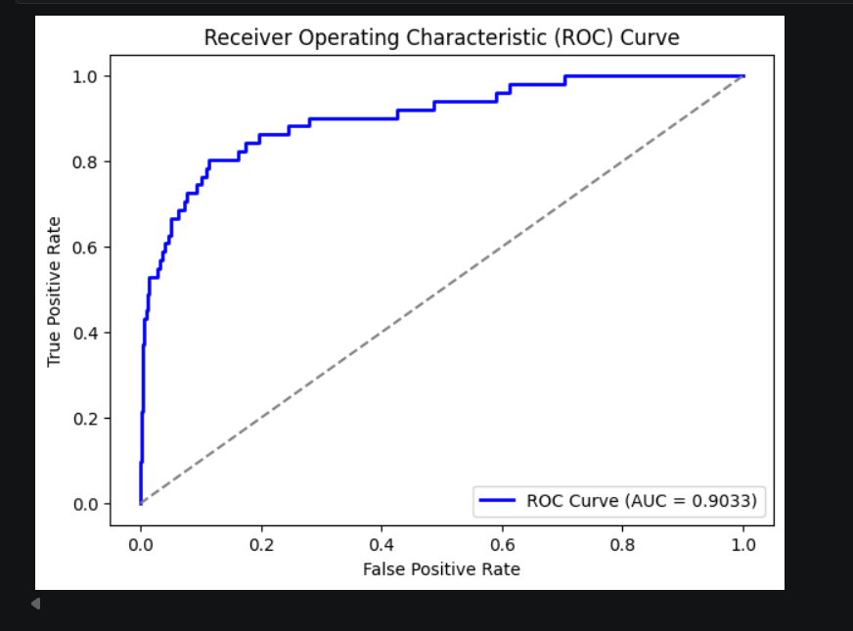

- Plot the Precision-Recall curve for your model using sklearn.metrics.precision_recall_curve and matplotlib, and explain in one line why this curve is useful for imbalanced datasets.Focus on how precision and recall behave when the positive class is rare.
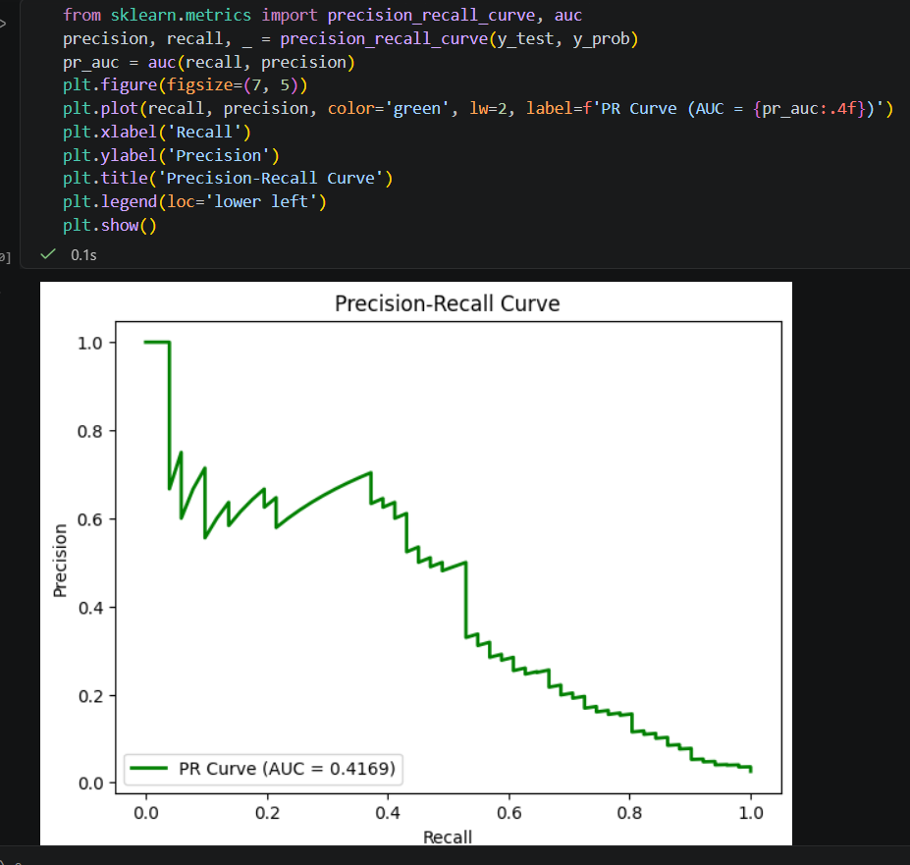

Why it's useful: The Precision-Recall curve is critical for highly imbalanced datasets because it focuses exclusively on the minority positive class, whereas ROC curves can present an overly optimistic picture of performance due to the massive number of true negatives.

- Calculate the log loss (cross-entropy loss) for your test set predictions using sklearn.metrics.log_loss and print the result.

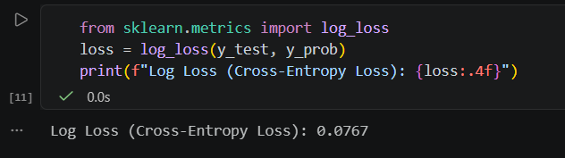

- Change the class distribution in your test set to be even more imbalanced (e.g., only 2% positive class), re-calculate accuracy, AUC, and log loss, and write 2 lines explaining which metric is most misleading and why.Accuracy can be high even if the model ignores the minority class.
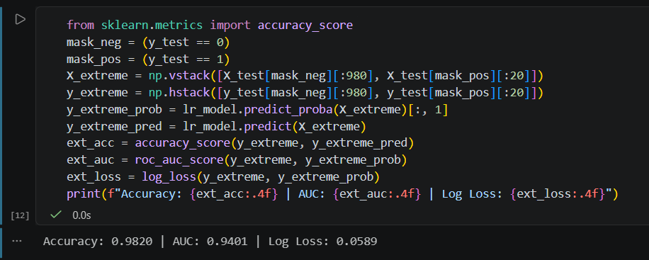

Most Misleading Metric: Accuracy is the most misleading metric because a naive model that completely ignores fraud and predicts all transactions as normal would still achieve a 98% accuracy score, while completely failing to catch any fraudulent activity.

